1. For simple java platform scripting can use cucumber and Jbehave tool

And for .net platform use SpecFlow tool.

2. JAR file to be added

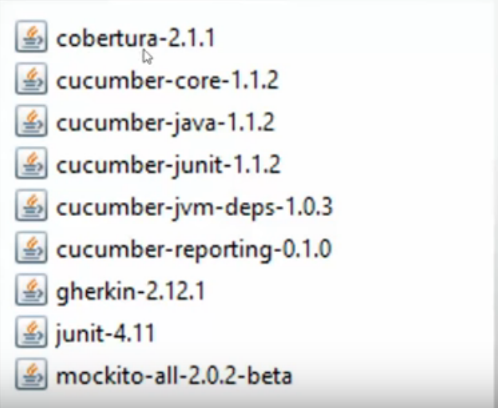

- Create a simple java project.

- in libraries add cucumber jar files.

- Add selenium jar files (2.53 version). (seleniumhq.org)

- Finish the process.

- to create a feature file

- create a new folder(name it accordingly) under created project.



Add a plugin from above path. Go help-> Install new software in eclipse and paste it.

- Create a new file under the new folder. (With .feature extension)

Note: Gherkins keywords will always start with caps.

Don’t give space b/w Gherkins keywords and colon.

Can write a gherkins code in feature file.

Need a Test runner to execute a program. Create a java class under project.

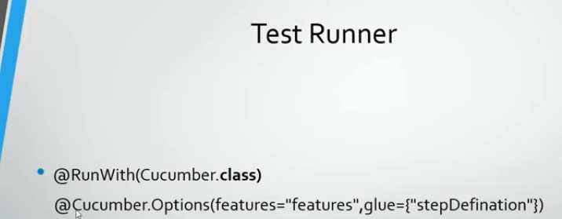

Note: @Cucumber.Option command is used in older versions. For new one @ CucumberOption.

After running the java class. Copy the skeleton generated in console and paste it in the new class – step definition. Create Package -> class.java and paste

Integrate the code with selenium i.e create driver etc.

Add glue : in test runner. i.e it will instruct where the step definition file is present.

* Parameter passing in cucumber without example and with example.

In without example:

Pass the parameter from feature file in “ ”.

Run the testrunner, then u will get a code generated. Copy that and paste it into the step definition.

i.e accept the parameter in step defi

*** while creating maven project add dependencies of selenium, junit, cucumber-java, cucumber-junit

Various reports can be generated in cucumber like html, json,xml etc

For html report add html plugin 

** Comments can be added using symbol #

**Important Terms used in Gherkin**

* Feature
* Background
* Scenario
* Given
* When
* Then
* And
* But
* Scenario Outline Examples